**[Baker Mayfield the Baseball Prophet](https://www.fangraphs.com/community/?p=75980" \o "Permanent link to Baker Mayfield the Baseball Prophet)**

by [Pete Berryman](https://www.fangraphs.com/community/author/pjb0009/)

October 10, 2018

Baker Mayfield has been labeled as many things over the course of his football career. He was once called a walk-on. He was once called a transfer. He has been called a bad boy. He has been called arrogant, disrespectful, gutsy, bold, talented, and a leader. He is even a Heisman Trophy winner and a first overall pick. However, I doubt many people have called Baker Mayfield a baseball prophet. Maybe it is too soon to call him that, but hear me out. On September 20th, 2018, Mayfield led the Cleveland Browns to their first win since December 24th, 2016. The media had already been fascinated by this energetic gunslinger for years, but September 20th was truly Baker’s moment in the spotlight. As the city of Cleveland celebrated more intensely than most cities’ Super Bowl celebrations, Mayfield entertained the media late into the night. As he stood to leave the postgame press conference, Mayfield threw in [**six final words**](https://www.youtube.com/watch?v=jDxEuLteWNE) that no one could have predicted: “…and Christian Yelich for NL MVP.”

Top of Form

Bottom of Form

What? Why? Huh?

[**Baker sported a Yelich jersey**](https://www.wbay.com/content/sports/Baker-Mayfield-supports-Brewers-star-Christian-Yelich--493997271.html) as he entered the stadium that day, but why on Earth did he make this random comment after a night that was truly his? It does appear that [**they are friends**](https://twitter.com/bakermayfield/status/960982902388355072?ref_src=twsrc%5Etfw%7Ctwcamp%5Etweetembed%7Ctwterm%5E960982902388355072&ref_url=https%3A%2F%2Fwww.jsonline.com%2Fstory%2Fsports%2Fmlb%2Fbrewers%2F2018%2F02%2F16%2Fcamp-report-christian-yelich-explains-why-baker-mayfield-wears-brewers-gear%2F330765002%2F), but what matters is the result of Baker’s shoutout, not the motive. Anyways, Baker Mayfield is famous, but he has no say-so in the NL MVP voting, so it was really just an entertaining mic drop to finish the night. Or was it?

Top of Form

Bottom of Form

Christian Yelich went from MVP candidate to MVP front-runner in the 10 games that followed this shoutout from Baker Mayfield. Plain and simple. He was having an excellent season leading up to the night of September 20th, mostly thanks to a blazing second half of the season. But do not be mistaken! Yelich somehow got even hotter after Baker gave him this public support. He completed the 2018 regular season 1 HR and 2 RBIs away from the NL Triple Crown. When you see the results that came after Baker’s press conference, it’s no surprise that Yelich was nearly the first NL Triple Crown winner since the St. Louis Cardinals’ Joe Medwick in 1937:

One of the best hitting statistics to fairly evaluate hitting performance is wRC+. In the words of FanGraphs, “wRC+ is the most comprehensive rate statistic used to measure hitting performance because it takes into account the varying weights of each offensive action and then adjusts them for the park and league context in which they took place.” So, for the sake of equal comparison to Yelich’s peers in the National League, let’s see where he stood in the NL wRC+ rankings on September 20th:

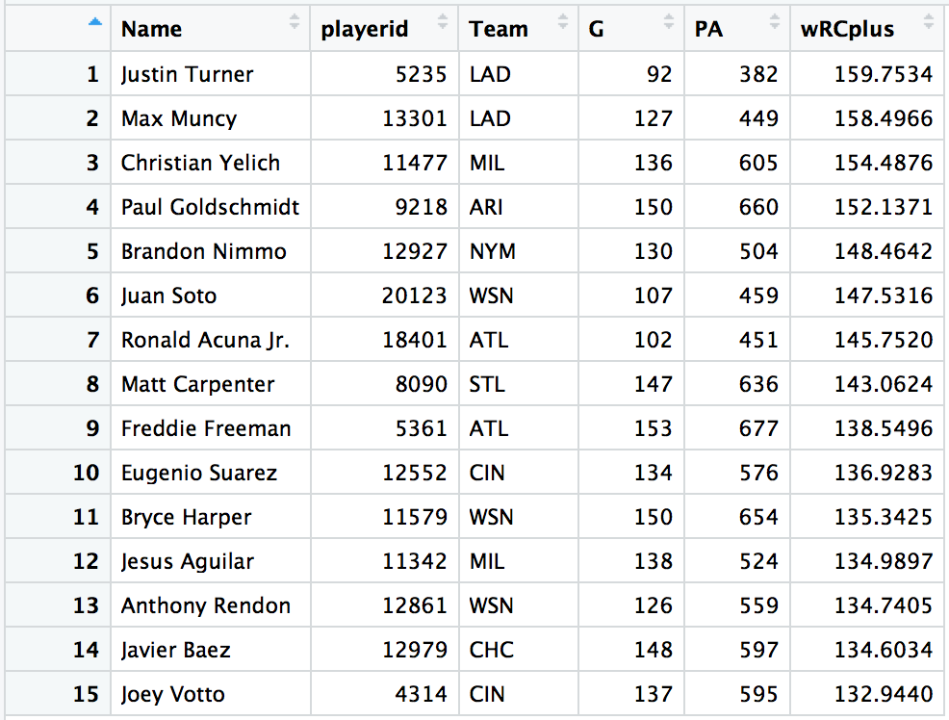

Clearly having a great season, Yelich sat at third in the wRC+ rankings. He was indeed a very strong MVP candidate, but there were other names such as Matt Carpenter, Javy Baez, Freddie Freeman, and even Jacob DeGrom that threatened his chances at coming away with the MVP award. Baez, thanks to his wicked defense and aggressive base running, appeared to be a particularly viable threat for the award.

Then, Baker Mayfield publicly jumped on the Christian Yelich bandwagon. Here are the wRC+ rankings over the 11 days from September 21st through the end of the regular season:

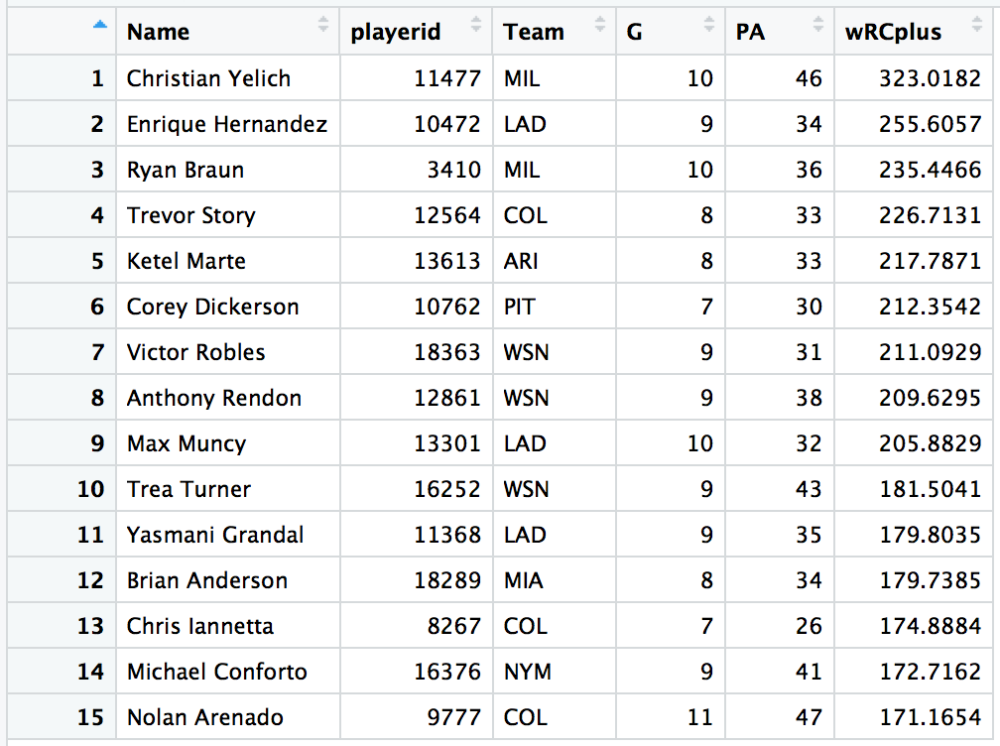

Pure domination. A sensational hot streak. A stretch where Yelich reached base in 63% of his plate appearances. This stretch to end the season was exactly what had to happen for the 26-year-old outfielder to earn his first MVP honors in a promising young career. Here is how the wRC+ rankings looked at the end of the 2018 season:

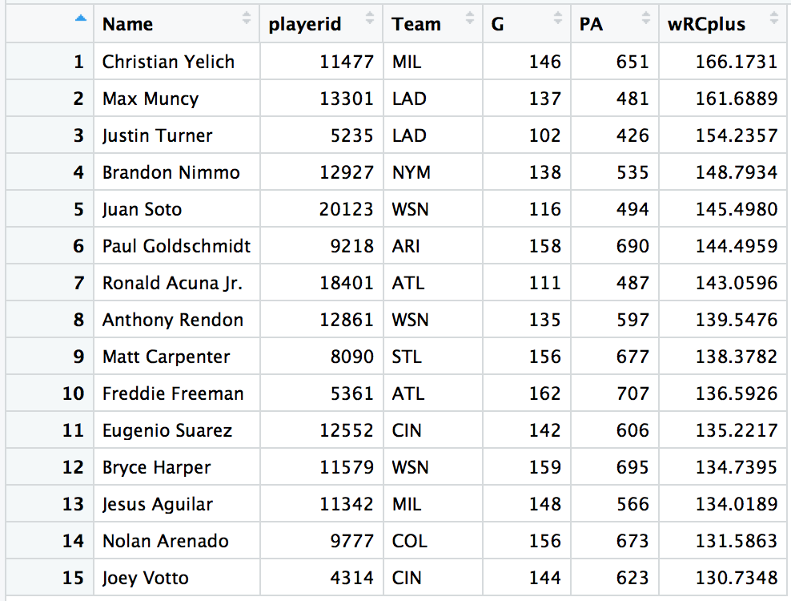

Interestingly enough, Mayfield’s shoutout to Yelich’s excellent season did not just *improve* Christian Yelich. All of a sudden, he even got *luckier*. Not to take away from how well he hit the ball over the last week and a half, but Statcast measures the expected wOBA of a hit based on the exit velocity and launch angle of the hit. When you take difference between a player’s wOBA and his xwOBA, you find whether or not his results have been more or less successful than expected depending on the quality of his contact. Here is how Yelich’s wOBA – xwOBA measurement varied throughout the season:

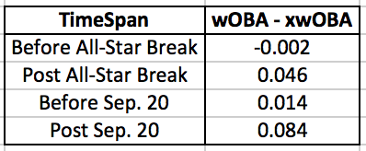

Apparently, Yelich’s wOBA was expected to be a very nice 0.573 over the last 10 games, but the actual wOBA came out to a whopping 0.657. Is Mayfield as magical as they say he is? Are his miraculous scrambles and unthinkable completions the only ways he does the impossible? It’s hard to say. All I know is that Christian Yelich has reached base in 8 of 14 plate appearances, homered once, and stolen two bases so far this postseason and has led the red-hot Brewers to the NLCS. If Baker Mayfield starts endorsing other athletes and blessing them with his MVP vote, it seems as though we must watch, listen, and be amazed.

“I’m going to speak it into existence.”     –Lavar Ball… or Baker Mayfield

#YelichForMVP